**SUBCRIBER’S GALORE: EXPLORING THE WORLD’S TOP YOUTUBE CHANNELS**

**GROUP I’D: NM2023TMID15970**

# INTRODUCTION:

A subscriber to a channel on the video-sharing You Tube is a user who has chosen to receive the channel’s content by clicking on that channel’s “subscribe” button, and each user’s subscription feed consists of videos published by channels to which the user is subscribed.

The following table lists the 50 most-subscribed YouTube channels, as well as the primary language and content category of each channel.

# EMPATHY MAPPING

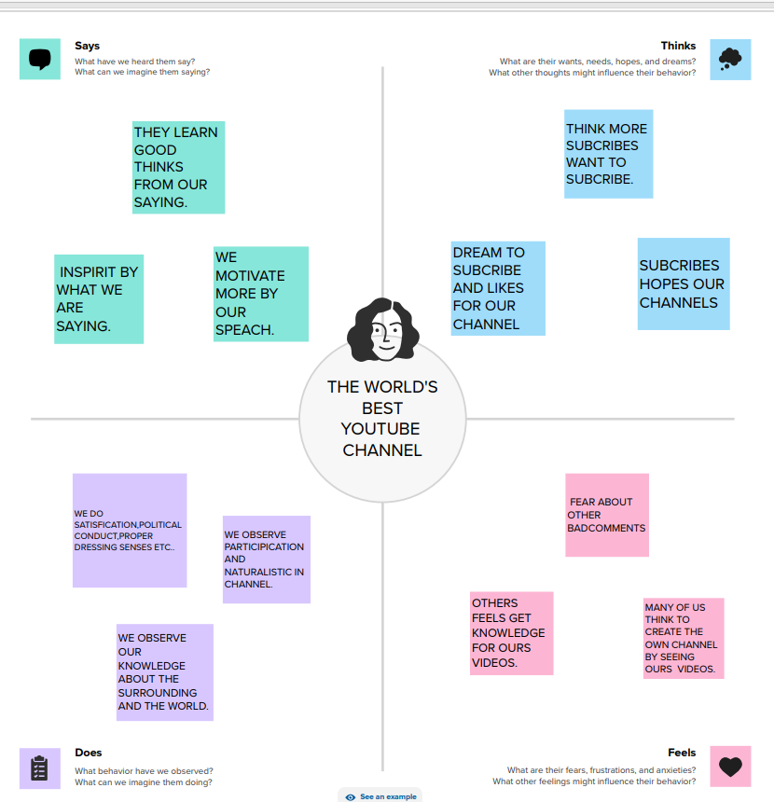

# BRAINSTROM

# RESULT

DASHBOARD1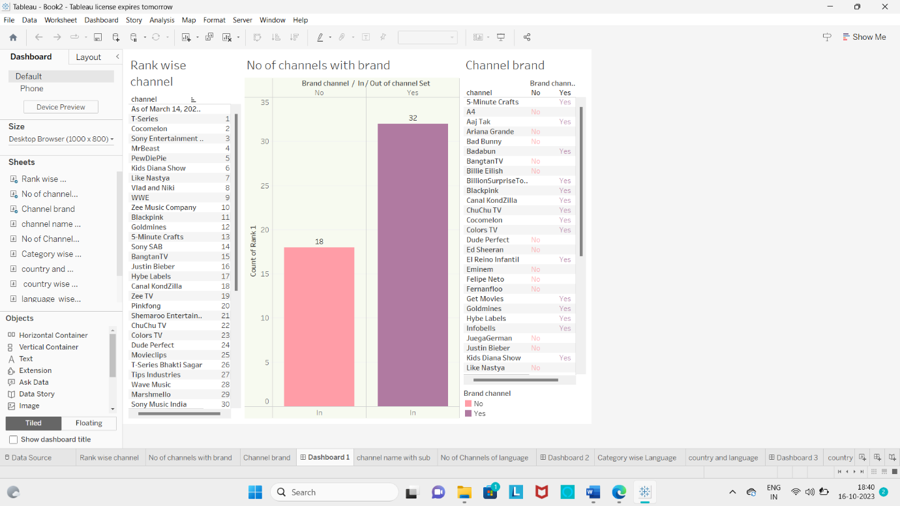

DASHBOARD2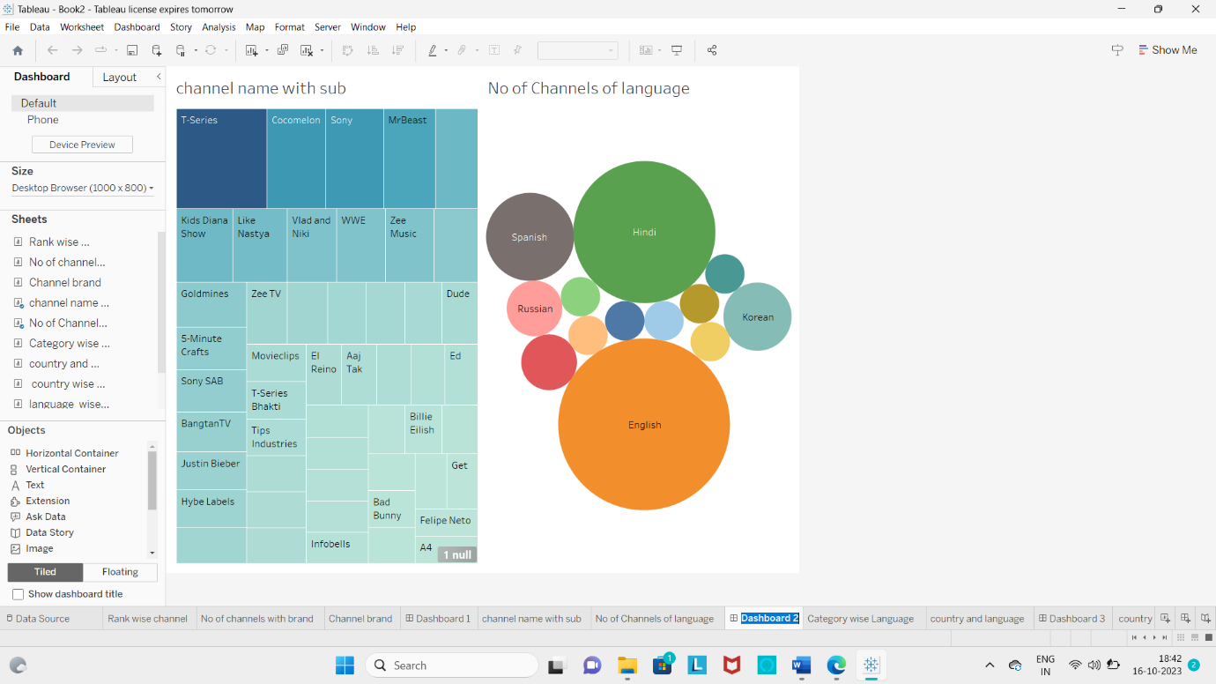

DASHBOARD3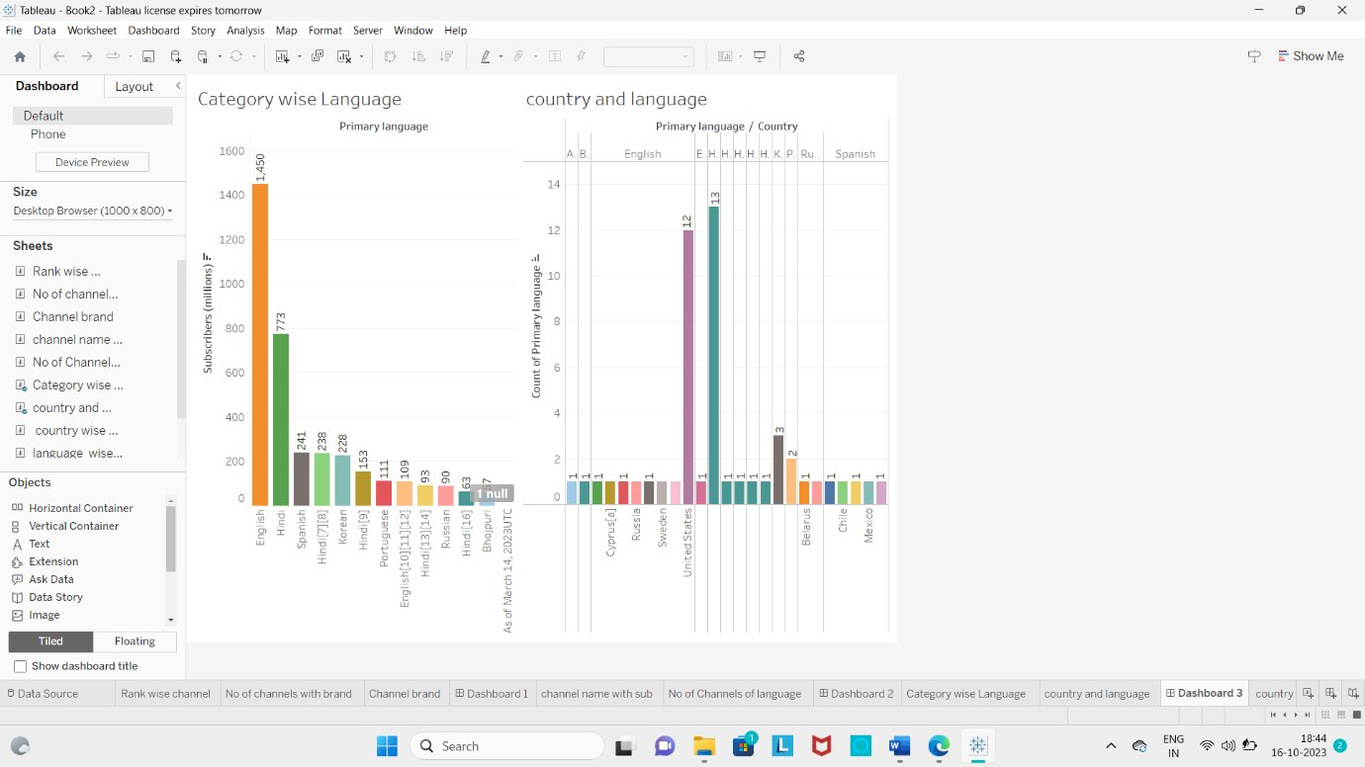

DASHBOARD4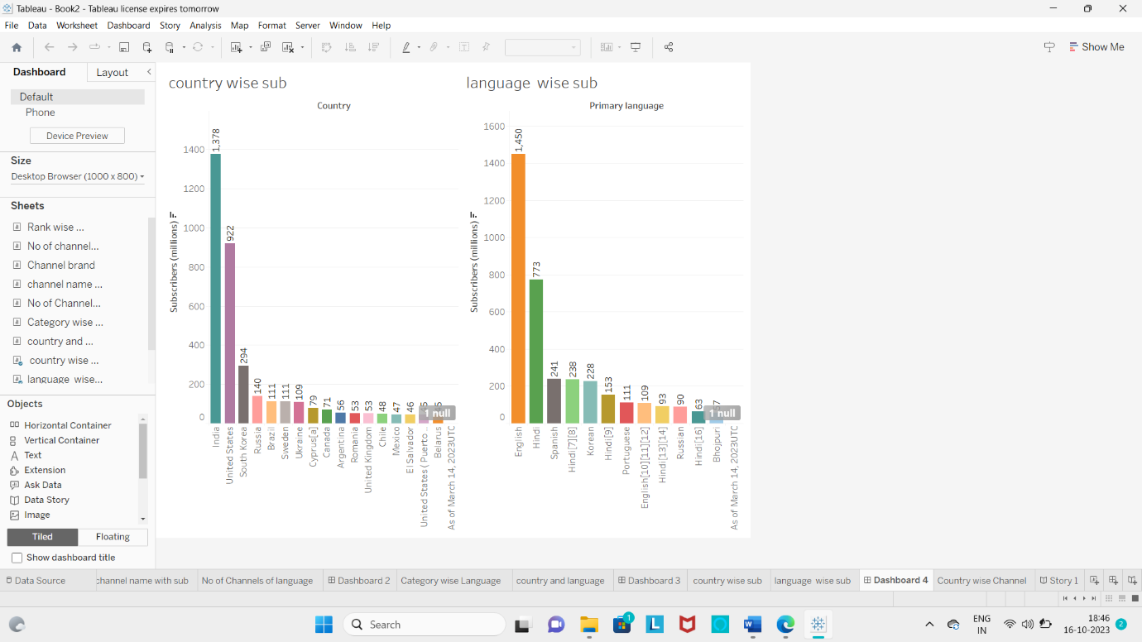

DASHBOARD5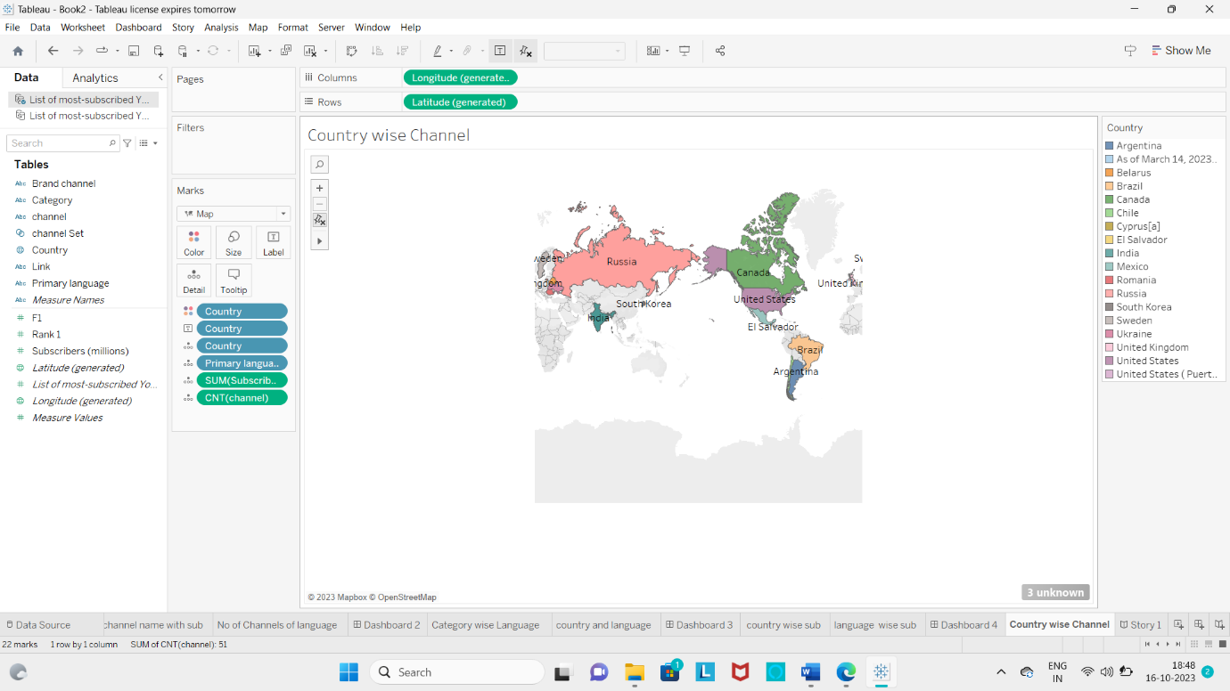

# ADVANTAGES

**You Tube videos are easily shareable and something we recommand you post across your other social media platforms.**

**Our project expalin about the subscribers who subscribe the minimun or maximun languages, country, brands, ranks of channel, etc…**

**By using visual elements such as charts, graphs, maps, data visualization can help people quickly identity patternsm trends and outliers in the data.**

# DISAVANTAGES

**We use only the mininum of channels.**

**We not explain about the posts, views, likes, commands,etc.. about the channels.**

# APPLICATIONS

**YouTube has transformed the way we consume content, and it's no secret that the platform is home to a plethora of popular and influential channels. In this article, we will embark on a journey to explore some of the world's top YouTube channels with subscribers galore.**

**1. T-Series:**

**With a staggering subscriber count of over 164 million, T-Series holds the title for the most subscribed YouTube channel. It is an Indian music label and film production company. T-Series is known for its vast catalog of Bollywood music videos, as well as Indian film trailers and other entertaining content.**

**2. PewDiePie:**

**Although no longer the most subscribed channel, PewDiePie maintains an enormous following with over 110 million subscribers. Felix Kjellberg, the Swedish internet personality behind the channel, initially gained fame through his video game playthroughs and humorous commentaries. His content has now expanded to include various vlogs and collaborations with other YouTubers.**

**These are just a few examples of the top YouTube channels with colossal subscriber bases. Each channel offers unique content that resonates with its audience, showcasing the diverse interests and preferences of YouTube viewers worldwide.**

# CONCLUSION

**In conclusion, Subscribers Galore has proven itself to be one of the world's top YouTube channels, creating a massive impact in the digital sphere. With its extensive subscriber base, engaging content, and consistent growth, the channel has climbed the ladder of success and established itself as a force to be reckoned with.**

**The success of Subscribers Galore also stems from its commitment to innovation. By staying updated with the latest YouTube trends, experimenting with new formats, and embracing emerging technologies, the channel remains fresh and ahead of the competition.**